- Given below are two statements:
Statement I: To cross a river in minimum time, a person should swim perpendicular to river flow.
Statement II: The drift of man along the flow is independent of time.
In light of the above statements, choose the most appropriate answer from the options given below:
(1) Statement I is correct but statement II is incorrect.
(2) Statement II is correct but statement I is incorrect.
(3) Both statements are incorrect
(4) Both statements are correct.
- A stone projected with a velocity u at an angle $θ$ with the horizontal reaches maximum height H₁. When it is projected with velocity u at an angle $\left(\frac{π}{2}-θ\right)$ with the horizontal, it reaches maximum height H₂. The relation between the horizontal range R of the projectile, H₁ and $H_{2}$ is
(1) $R=4\sqrt{H_{1}H_{2}}$ (2) $R=4\left(H_{1}-H_{2}\right)$
(3) $R=4\left(H_{1}+H_{2}\right)$ (4) $R=\frac{H_{1}^{2}}{H_{2}^{2}}$
- The path of a projectile in the absence of air drag is shown in the figure by dotted line. If
the air resistance is not ignored then which one of the paths shown in the figure is appropriate
for the projectile?
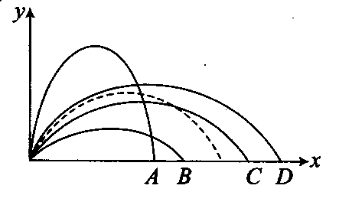
(1)B (2)A (3)D (4)C
- Which of the following is the graph between the height (h) of a projectile and time (t), when it is projected from the ground? Ans(3)
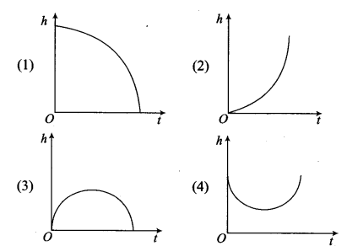
- A frictionless track ABCDE ends in a circular loop of radius r. A body slides down the track from point A which is at a height h = 5 cm. Maximum value of r for the body to successfully complete the loop is
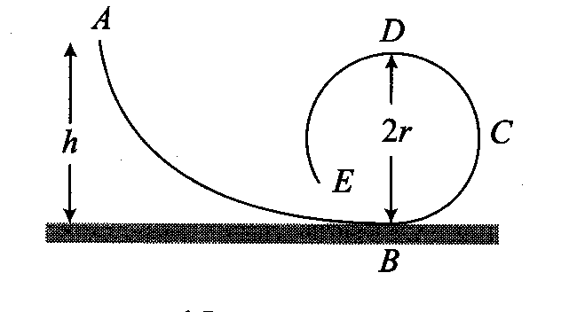
(1) 5 cm (2) $\frac{15}{4}$ cm (3) $\frac{10}{3}$ cm (4) 2 cm
- A particle of mass m at rest is acted upon by a force F for a time t. Its kinetic energy after an interval t is
(1)$\frac{F^{2}t^{2}}{m}$ (2)$\frac{F^{2}t^{2}}{2m}$ (3) $\frac{F^{2}t^{2}}{3m}$ (4) $\frac{Ft}{2m}$
- A mass of 100 g strikes the wall with speed 5 m/s at an angle as shown in figure and it rebounds with the same speed. If the contact time is $2×{10}^{-3}s$ ,what is the force applied on the mass by the wall?
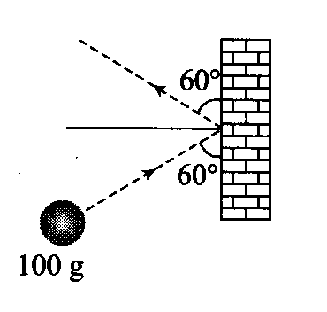
(1) 250$\sqrt{3}$ N to right (2) 250 N to right
(3) 250$\sqrt{3}$ N to left (4) 250 N to left
- Two springs of spring constants 1500 N/m and 3000 N/m respectively are stretched with the same force. They will have potential energy in the ratio
(1)4:1 (2)1:4 (3)2:1 (4)1:2
- The spring extends by x on loading, then energy stored by the spring is: (if T is the tension in spring and k is spring constant)
(1) $\frac{T^{2}}{2k}$ (2)$\frac{T^{2}}{2k^{2}}$ (3) $\frac{2k}{T^{2}}$ (4) $\frac{{2T}^{2}}{k}$
- The potential energy between two atoms in a molecule is given by $U\left(x\right)=\frac{a}{x^{12}}-\frac{b}{x^{6}}$; where a and b are positive constants and x is the distance between the atoms. The atom is in stable equilibrium when
(1)$x=\sqrt[6]{\frac{11a}{5b}}$ (2)$x=\sqrt[6]{\frac{a}{2b}}$ (3)x=0 (4)$x=\sqrt[6]{\frac{2a}{b}}$
- A ball is released from the top of a tower. The ratio of work done by force of gravity in first, second and third second of the motion of the ball is
(1) 1:2:3 (2) 1:4:9 (3) 1:3:5 (4) 1:5:3
- The block of mass M moving on the frictionless horizontal surface collides with the spring of spring constant k and compresses it by length L. Then, maximum M momentum of the block after collision is
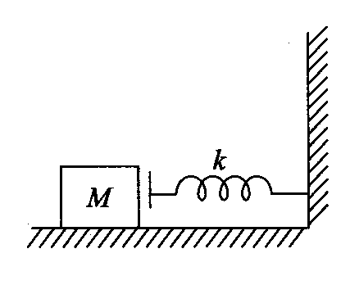
(1) $L\sqrt{MK}$ (2) $\frac{kL^{2}}{2M}$ (3) Zero (4) $\frac{ML^{2}}{K}$
- A sphere of mass m moving with a constant velocity u hits another stationary sphere of the same mass. If e is the coefficient of restitution, then the ratio of the velocity of two spheres after collision will be
(1) $\frac{1-e}{1+e}$ (2) $\frac{1+e}{1-e}$ (3) $\frac{e+1}{e-1}$ (4) $\frac{e-1}{e+1}$
- A cannon ball is fired with a velocity 200 m/sec at an angle of 60⁰ with the horizontal. At the highest point of its flight it explodes into 3 equal fragments, one going vertically upwards with a velocity 100 m/sec, the second one falling vertically downwards with a velocity 100 m/sec. The third fragment will be moving with a velocity
(1) 100 m/s in the horizontal direction
(2) 300 m/s in the horizontal direction
(3) 300 m/s in a direction making an angle of 60° with the horizontal
(4) 200 m/s in a direction making an angle of 60° with the horizontal
- Given below are two statements:
Statement I: Friction opposes relative motion.
Statement II: Static friction is self adjusting while kinetic friction is constant.
(1) Statement I is correct but statement II is incorrect.
(2) Statement II is correct but statement I is incorrect.
(3) Both statements are incorrect
(4) Both statements are correct.
- A particle moves in a circle of radius 20 cm with constant angular velocity 5 rev/sec. The average speed in one time period of rotation is
(1) 10$π$ m/s (2)2$π$ m/s (3) 3$π$ m/s (4)4$π$ m/s
- A ball is suspended by a thread of length L. What minimum horizontal velocity has to be imparted to the ball for it to reach the height of suspension?
(1) $\sqrt{gL}$ (2) $\sqrt{2gL}$ (3)$\sqrt{5gL}$ (4)$\sqrt{4gL}$
- The force acting on a particle is given by$F=λs^{2}$ , where $λ$ is constant and s is displacement. The kinetic energy is proportional to
(1) s (2) s² (3) s³ (4) s⁴
- The velocity of a particle of mass 100 g is given by $ν$ =4 + 8t + t². The work done in first 2 sec is
(1) 7 J (2) 14 J (3) 21 J (4) 28 J
- A particle falls from a height h upon a fixed horizontal plane and rebounds. If e is the coefficient of restitution, the total distance travelled before rebounding has stopped is
(1) $h\left(\frac{1+e^{2}}{1-e^{2}}\right)$ (2) $h\left(\frac{1-e^{2}}{1+e^{2}}\right)$
(3) $\frac{h}{2}\left(\frac{1-e^{2}}{1+e^{2}}\right)$ (4) $\frac{h}{2}\left(\frac{1+e^{2}}{1-e^{2}}\right)$
- A big ball of mass M, moving with velocity u strikes a small ball of mass m, which is at rest. Finally small ball obtains velocity u and big ball obtains 𝜈. Then what is the value of 𝜈 ?
(1) $\frac{M-m}{M+m}u$ (2) $\frac{m}{M+m}u$ (3)$\frac{2m}{M+m}u$ (4) $\frac{M}{M+m}u$
- Two masses $m_{A}$ and $m_{B}$ moving with velocities $ν_{A}$ and $ν_{B}$ in opposite directions collide elastically. After that the masses $m_{A}$ and $m_{B}$ move with velocity $ν_{B}$ and $ν_{A}$A respectively. The ratio ($m_{A}$/$m_{B}$) is
(1) 1 (2) $\frac{ν_{A}-ν_{B}}{ν_{B}+ν_{B}}$
(3) ($m_{A}$/$m_{B}$)/$m_{A}$ (4) $ν_{A}/ν_{B}$
- Which of the following statements is true?
(1) In elastic collisions, the momentum is conserved but not in inelastic collisions
(2) Both kinetic energy and momentum are conserved in elastic as well as inelastic collisions
(3) Total kinetic energy is not conserved but momentum is conserved in inelastic collisions
(4) Total kinetic energy is conserved in elastic collisions but momentum is not conserved in elastic collisions.
- A mass ‘m’ moves with a velocity ‘𝜈’ and collides inelastically with another identical mass. After collision the 1st mass moves with velocity $\frac{ν}{\sqrt{3}}$ in a direction perpendicular to the initial direction of motion. Find the speed of the 2nd mass after collision
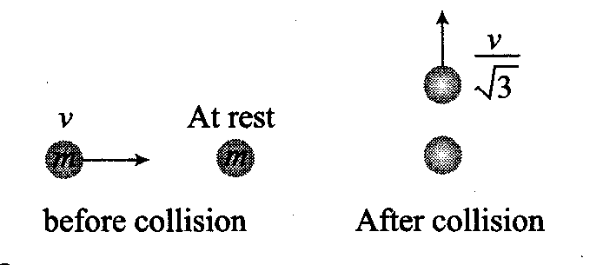
(1) $\frac{2}{\sqrt{3}}ν$ (2) $\frac{ν}{\sqrt{3}}$ (3) 𝜈 (4) $\sqrt{3}$𝜈
- A bag (mass M) hangs by a long thread and a bullet (mass m) comes horizontally with velocity 𝜈 and gets caught in the bag. Then for the combined (bag + bullet) system
(1) Momentum is $\frac{mvM}{M+m}$
(2) Kinetic energy is $\frac{mv^{2}}{2}$
(3) Momentum is $\frac{mv\left(M+m\right)}{M}$
(4) Kinetic energy $\frac{m^{2}v^{2}}{2\left(M+m\right)}$
- A bullet of mass m moving with velocity v strikes a block of mass M at rest and gets embedded into it. The kinetic energy of the composite block will be
(1) $\frac{1}{2}mv^{2}× \frac{m}{\left(m+M\right)}$ (2) $\frac{1}{2}mv^{2}× \frac{M}{\left(m+M\right)}$
(3) $\frac{1}{2}mv^{2}× \frac{\left(M+m\right)}{M}$ (4) $\frac{1}{2}Mv^{2}× \frac{m}{\left(m+M\right)}$
- A body of mass 4kg moving with velocity 12 m/s collides with another body of mass 6 kg at rest. If two bodies stick together after collision, then the loss of kinetic energy of
system is
(1) Zero (2) 288 J (3) 172.8 J (4) 144 J
- A heavy body moving with a velocity 30 m/ s and another small object at rest undergo an elastic collision. The latter will move with a velocity of
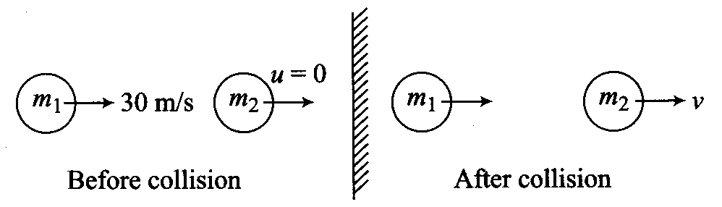
(1) 30 m/s (2) 60m/s (3) 80 m/s (4) Zero.
- Given below are two statements one is labelled as Assertion (A) and the other is labelled as Reason (R).
Assertion (A): Work cannot be added to force.
Reason (R): Their dimensions are different.
In the light of above statements, choose the most appropriate answer from the options given below:
(1) Both A and R are true and R is the correct explanation of A.
(2) Both A and R are true but R is not the correct explanation of A.
(3) A is true, R is false
(4) A is false, R is false
- A body of mass m moving along a straight line collides with a body of mass nm which is also moving with a velocity kv in the same direction. If the first body comes to rest after the collision, then the velocity of second body after the collision would be
(1) $\frac{nv}{\left(1+nk\right)}$ (2)$\frac{nv}{\left(1-nk\right)}$ (3) $\frac{\left(1+nk\right)}{n}$ (4) $\frac{\left(1+nk\right)v}{n}$
- A sphere of mass 0.1 kg is attached to a cord of 1m length. Starting form the height of its point of suspension this sphere hits a block of same mass at rest on a frictionless table. If the impact is elastic, the kinetic energy of the block after the collision is
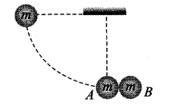
(1) 1J (2) 10 J (3) 0.1 J (4) 0.5 J
- A ball of mass 1 kg, moving with a velocity of 0.4 m/s collides with another stationery ball. After the collision, the first ball moves with a velocity of 0.3 m/s in a direction making an angle of 90⁰ with its initial direction. The momentum of second ball after collision will be (in kg-m/s)
(1) 0.1 (2) 0.3 (3) 0.5 (4) 0.7
- Vector $\vec{A }$ makes equal angles with x, y and z axis. Value of its components (in terms of magnitude of $\vec{A }$ ) will be
(1) $\frac{A}{\sqrt{3 }}$ (2)$\frac{A}{\sqrt{2 }}$ (3)$\sqrt{3 }A$ (4) $\frac{\sqrt{3 }}{A}$
- The resultant of $\vec{P }$ and $\vec{Q }$ is perpendicular to $\vec{P }.$ What is the angle between $\vec{P }$ and $\vec{Q }$?
(1) $\cos^{-1}{(P/Q) }$ (2) $\cos^{-1}{(-P/Q) }$
(3) $\sin^{-1}{(P/Q) }$ (4) $\sin^{-1}{(-P/Q) }$
- Three concurrent forces of the same magnitude are in equilibrium. What is the angle between the forces? Also name the triangle formed by the forces considering as sides.
(1) 60° equilateral triangle
(2) 120° equilateral triangle
(3) 120°, 30°, 30° an isosceles triangle
(4) 120° an obtuse angled triangle
Section B

- The angle between two vectors given by $6\hat{i}+6\hat{j}-3\hat{k}$ and $7\hat{i}+4\hat{j}+4\hat{k}$k is
(1) $\cos^{-1}\left(\frac{1}{\sqrt{3}}\right)$ (2) $\cos^{-1}\left(\frac{5}{\sqrt{3}}\right)$
(3) $\sin^{-1}\left(\frac{2}{\sqrt{3}}\right)$ (4) $\cos^{-1}\left(\frac{2}{3}\right)$
- A person aiming to reach the exactly opposite point on the bank of a stream is swimming with a speed of 0.5 m/s at an angle of 120⁰ with the direction of flow of water. The speed of water in the stream is
(1) 1 m/s (2) 0.5 m/s
(3) 0.25 m/s (4) 0.433 m/s
- The length of second’s hand in watch is 1 cm. The change in velocity of its tip in 15 seconds is
(1) Zero (2) $\frac{π}{30\sqrt{2}}$ cm/sec
(3) $\frac{π}{30}$cm/sec (4) $\frac{π\sqrt{2}}{30}$ cm/sec
- A metal sphere is hung by a string fixed to a wall. The sphere is pushed away from the wall by a stick. The forces acting on the sphere are shown in the second diagram. Which of the
following statements is wrong?
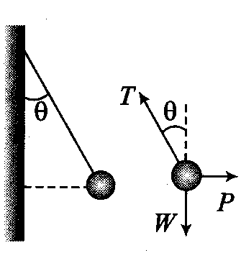
(1) $P=W\tan{θ}$ (2) $\vec{T}+\vec{P}+\vec{W}=0$
(3) $T^{2}=P^{2}+W^{2}$ (4) T=P+W
- Which of the following options is correct for the object having a straight line motion represented by the following graph?
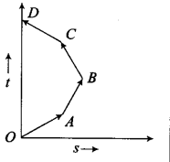
(1) The object moves with constantly increasing velocity from O to A and then it moves with constant velocity.
(2) Velocity of the object increases uniformly
(3) Average velocity is zero
(4) The graph shown is impossible
- The relation between time and distance is $t=αx^{2}+βx$, where $α$ and $β$ are constants. The retardation is
(1) $2αν^{3}$ (2) $2βν^{3}$ (3) $2αβν^{3}$ (4) $2β^{2}ν^{3}$
- A police jeep is chasing with velocity of 45 km/h, a thief in another jeep moving with velocity 153 km/h. Police fires a bullet with muzzle velocity of 180 m/s. The velocity it will strike the car of the thief is
(1) 150 m/s (2)27 m/s
(3) 450 m/s (4) 250 m/s
- A body is slipping from an inclined plane of height h and length l. If the angle of inclination is $θ$, the time taken by the body to come from the top to the bottom of this inclined plane is
(1) $\sqrt{\frac{2h}{g}}$ (2) $\sqrt{\frac{2l}{g}}$ (3)$\frac{1}{sinθ}\sqrt{\frac{2h}{g}}$ (4) $sinθ\sqrt{\frac{2h}{g}}$
- Three different objects of masses $m_{1},m_{2}$ and $m_{3}$ are allowed to fall from rest and from the same point ‘O’ along three different frictionless paths. The speeds of the three objects, on reaching the ground, will be in the ratio of
(1) $m_{1}:m_{2}:m_{3}$ (2) $m_{1}:{2m}_{2}:{3m}_{3}$
(3) 1:1:1 (4) $\frac{1}{m_{1}}:\frac{1}{m_{2}}:\frac{1}{m_{3}}$
- A car accelerates from rest at a constant rate $α$ for some time, after which it decelerates at a constant rate $β$ and comes to rest. If the total time elapsed is t, then the maximum velocity acquired by the car is
(1) $\left(\frac{α^{2}+β^{2}}{αβ}\right)t$ (2) $\left(\frac{α^{2}-β^{2}}{αβ}\right)t$
(3) $\frac{\left(α+β\right)t}{αβ}$ (4) $\frac{αβt}{α+β}$
- An object is moving with a uniform acceleration which is parallel to its instantaneous direction of motion. The displacement (s)-velocity (v) graph of this object is Ans(3)
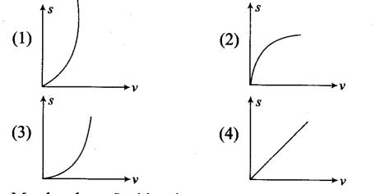
- Match column I with column II
Column I |  | Column II
(i) | Curie | (A) | MLT⁻²
(ii) | Light year | (B) | M
(iii) | Dielectric strength | (C) | Dimensionless
(iv) | Atomic weight | (D) | T
(v) | Decibel | (E) | $ML^{2}T^{-2}$
 |  | (F) | M$T^{-3}$
 |  | (G) | $T^{-1}$
 |  | (H) | L
 |  | (I) | ML$T^{-3}I^{-1}$
 |  | (J) | L$T^{-1}$

Choose the correct match:
(1) (i) G, (ii) H, (iii) C, (iv) B, (v) C
(2) (i) D, (ii) H, (iii) I, (iv) B, (v) G
(3) (i) G, (ii) H, (iii) I, (iv) B, (v) G
(4) None of the above
- A body travels uniformly a distance of (13.8 ± 0.2)m in a time (4.0 ± 0.3) s. The velocity of the body within error limits is
(1) (3.45 ± 0.2) ms⁻¹ (2) (3.45 ± 0.3) ms⁻¹
(3) (3.45 ± 0.4) ms⁻¹ (4) (3.45 ± 0.5) ms⁻¹
- The pair having the same dimensions is
(1) Angular momentum, work
(2) Work, torque
(3) Potential energy, linear momentum
(4) Kinetic energy, velocity
- The period of oscillation of a simple pendulum is given by $T=2π\sqrt{\frac{l}{g}}$ where l is about 100 cm and is known to have 1 mm accuracy. The period is about 2s. The time of 100
oscillations is measured by a stop watch of least count 0.1s. The percentage error in g is
(1) 0.1% (2) 1% (3) 0.2% (4) 0.8%

CHEMISTRY
Section A
- In the absence of electric and magnetic field cathode rays travel in
(1) straight line
(2) deflected towards negative plate
(3) deflected towards positive plate
(4) All of the above
- Calculate the radius ratio of 2nd excited state of ‘H’ and 1st excited state of ${Li}^{++}$.
(1) 9/2 (2) 27/4 (3) 9/4 (4)27/9
- The wavelength range of visible spectrum extends from violet (400 nm) to red (750 nm) express these wavelengths in frequencies:
(1) $4×{10}^{14} Hz and 7.5×{10}^{14} Hz$
(2) $4×{10}^{14} Hz and 5×{10}^{14} Hz$
(3) $7.5×{10}^{14} Hz and 4×{10}^{14} Hz$
(4) $7.5×{10}^{14} Hz and 5×{10}^{14} Hz$
- If the de-Broglie wavelength of a particle of mass m is 25 times its velocity then its value in terms of its mass (m) and Plank’s constant (h) is
(1) $\frac{1}{5}\sqrt{\frac{m}{h}}$ (2) $5\sqrt{\frac{h}{m}}$ (3)$\frac{1}{5}\sqrt{\frac{h}{m}}$ (4) $5\sqrt{\frac{m}{h}}$
- The difference between the wave number of 1st line of Balmer series and last line for Paschen series for ${Li}^{2+}$ ion is:
(1) R/36 (2) 5R/36 (3) 4R (4) R/4
- In hydrogen atom, energy of first excited state is -3.4 eV. Then, PE of same orbit of hydrogen atom is:
(1) +3.4eV (2) -6.8eV (3) -13.6eV (4) +13.6 eV
- If the threshold wavelength, frequency of a metal surface are $λ_{0}$ and $f_{0}$ respectively but the incident wavelength and frequency are 𝜆 and f respectively then condition for emission of electron from metal surface:
(1)$λ>λ_{0} and f<f_{0}$ (2) $λ<λ_{0} and f<f_{0}$
(3) $λ<λ_{0} and f>f_{0}$(4) $λ>λ_{0} and f>f_{0}$
- Match the list-I with list-II
 | List-I |  | List-II
(a) | Radial node | (i) | l
(b) | Angular node | (ii) | n —l—1
(c) | Total node | (iii) | n
(d) | Nodal plane | (iv) | n—1

(1) a—(ii), b—(i), c—(iv), d—(iii)
(2) a—(ii), b—(i), c—(iv), d—(i)
(3) a—(i), b—(ii), c—(iii), d—(iv)
(4) a—(iv), b—(i), c—(ii), d—(iii)
- Given below are two statements one is labelled as Assertion (A) and the other is labelled as Reason (R).
Assertion (A): In case of isoelectronic ions the ionic size increases with the increase in atomic number.
Reason (R): The greater the attraction of nucleus greater the ionic radius.
In the light of above statements, choose the most appropriate answer from the options given below:
(1) Both (A) and (R) are correct and (R) is the correct explanation of (A)
(2) Both (A) and (R) are correct but (R) is not the correct explanation of (A)
(3) (A) is not correct but (R) is correct
(4) Both (A) and (R) are not correct
- Eka—Aluminiuni is also known as
(1) Silicon (2) Carbon
(3) Gallium (4) Germanium
- Match the List-I with List-I!:
 | List-I  (Atomic number) |  | List-II  (IUPAC)
(a) | 101 | (i) | Uuo
(b) | 104 | (ii) | Uut
(c) | 113 | (iii) | Unu
(d) | 118 | (iv) | Unq

(1) a—(iv), b—(i), c—(ii), d—(iii)
(2) a—(iii), b—(iv), c—(i), d—(ii)
(3) a—(iii), b—(iv), c—(ii), d—(i)
(4) a—(iv), b—(i), c—(iii), d—(ii)
- Which of the following statements are not correct regarding ionisation potential?
(A) It is independent of atomic radii.
(B) It increases with increase in atomic radii.
(C) It remains constant with increase in atomic radii.
(D) It decreases with increase in atomic radii.
Choose the correct answer from the options given below
(1) A, B, C Only (2) C, D Only
(3) A, B Only (4) B, C Only
- According to Mendeleev periodic law
(1) The properties of the elements are a periodic function of their atomic number.
(2) The properties of the elements are a periodic function of their atomic mass.
(3) The properties of elements are a periodic function of their Electronegativity.
(4) The properties of the elements are a periodic function of their physical properties.
- Which of the following option are correct regarding to the Law of Octaves of Newlands?
(A) Elements are arranged in increasing order of their atomic number.
(B) Elements are arranged in increasing order of their atomic weights.
(C) Every eighth element had properties similar to the first element.
(D) This law seemed to be true only for elements up to Calcium.
Choose the correct answer from the options given below
(1) B,C Only (2) A,C Only
(3) B, C, D Only (4) A, B, C Only
- Which one of the following species is diamagnetic in nature?
(1) ${He}_{2}^{+}$ (2) H₂ (3) $H_{2}^{+}$ (4) $H_{2}^{-}$
- The correct order of N — N bond energy is:
(1) $N_{2}>N_{2}^{+}>N_{2}^{-}>N_{2}^{2-}$ (2) $N_{2}^{+}>N_{2}^{-}>N_{2}^{-}>N_{2}$
(3) $N_{2}>N_{2}^{-}=N_{2}^{+}>N_{2}^{2-}$(4) $N_{2}^{-}>N_{2}=N_{2}^{+}>N_{2}^{-}$
- Among the following which compounds will show the highest lattice energy?
(1) KF (2) CsF (3) NaF (4) RbF
- The molecule BF₃ and NF₃ both molecules are covalent, but BF₃ is non-polar and NF₃ is polar. Its reason is
(1) in uncombined state boron is metal and nitrogen is gas
(2) B—F bond has no dipole moment whereas N—F bond has dipole moment
(3) the size of boron atom is smaller than nitrogen
(4) BF₃ is planar whereas NF₃ is pyramidal.
- $π$-bond is formed
(1) by overlapping of atomic orbitals on the axis of nuclei
(2) by mutual sharing of pi electron
(3) by sidewise overlapping of half filled p-orbitals
(4) by overlapping of s-orbitals with p-orbitals
- Number of bonds and number of lone pairs of S in SO₂
(1) Two $σ$, two $π$ and two lone pair
(2) Two $σ,$ one $π$ and zero lone pair
(3) Two $σ$, two $π$ and one lone pair
(4) None of these
- Which of the following molecule is not linear?
(1) C₂H₂ (2) BeH₂ (3) CO₂ (4) H₂O
- The number of electrons involved in the bond formation of N₂ molecule
(1) 2 (2)4 (3) 6 (4) 10
- The shapes of IF₅ and IF₇ are respectively
(1) tetragonal pyramidal and pentagonal bipyramiclal
(2) octahedral and pyramidal
(3) trigonal bipyramidal and square antiprismatic
(4) distorted square planer and distorted octahedral
- The number of antibonding electron pairs in $O_{2}^{2-}$ molecular ion on the basis of molecular orbital theory is-
(1)3 (2)8 (3)4 (4)2
- Given below are two statements:
Statement I: The electronegativity of any given element is not constant.
Statement II: Electronegativity varies depending on the element to which it is bound.
In light of the above statements, choose the most appropriate answer from the options given below:
(1) Statement I is incorrect and statement II is correct.
(2) Statement I is correct and statement U is incorrect.
(3) Statement I and statement II both are correct.
(4) Statement I and statement II both are incorrect.
- The smallest among the following ions is
(1) ${Na}^{+}$ (2)Mg²⁺ (3) Ba²⁺ (4)Al³⁺
- Atomic radii of fluorine and neon in angstrom units are respectively given by
(1) 0.762, 1.60 (2) 1.60, 1.60
(3) 0.72, 0.72 (4) None of these values
- Choose the incorrect statement in the following-
(a) When electronegativity of elements increases, the non-metallic character increases.
(b) More electropositive elements have metallic character.
(c) The oxide of more electronegative elements are basic in nature.
(d) The decrease in electronegativity down a group is accompanied by decrease in metallic properties of elements.
Choose the correct answer from the options given below:
(1) c only (2) a, b only
(3) b, c only (4) c, d only
- Boron has two isotopes, B-10 and B-11. The average atomic mass of Boron is found to be 10.80 u. Calculate the percentage abundance of B¹⁰ isotope
(1) 80 (2) 20 (3) 25 (4) 75
- 8 g H₂ 32 g O₂ is allowed to react to form water then which of the following statement is correct?
(1) O₂ is limiting reagent (2) O₂ is reagent in excess
(3) H₂ is limiting reagent
(4) 40 g water is formed
- The maximum number of molecules are present in:
(1) l5 L H₂ gas at STP (2) 5 L of N₂ gas at STP
(3) 0.5 g H₂ gas (4) 10 g of O₂ gas
- Calculate the amount of 50% H₂SO₄ required to decompose 25 g of (marble) calcium carbonate
(1)98g (2)49g (3) 24.5g (4) 196g
- A gas is found to contain 2.34 g of nitrogen and 5.34 g of oxygen. Simplest formula of the compound is
(1) N₂O (2) NO (3) N₂O₃ (4) NO₂
- In a 5.2 molal aqueous solution of methyl alcohol what will be the mole fraction of methyl alcohol?
(1) 0.190 (2) 0.086 (3) 0.050 (4) 0.100
- 10 mL of gaseous hydrocarbon on complete combustion gives 20 mL of CO₂ and 30 mL of H₂O(g). The hydrocarbon is
(1) C₄H₁₀ (2) C₂H₆ (3) C₄H₈ (4) C₈H₁₀
Section B
- Balmer and Lyman series comes under which spectral region
(1) Ultraviolet and Infrared
(2) Infrared and visible
(3) Visible and Ultraviolet
(4) Visible and Infrared
- Which of the following set of quantum numbers are not possible?
(1) n=0;l=0;m=0;s=+1/2
(2) n=1;l=0;m=0;s=-1/2
(3) n=2;l=1;m=0;s=+1/2
(4) n=3;l=1;m=-1;s=+1/2
- Given below are two statements: One is labelled as Assertion (A) and the other is labelled as Reason (R)
Assertion (A): K and Cs are used in photoelectric cells.
Reason (R): K and Cs emit electrons on exposure to light
In light of the above statements, choose the most appropriate answer from the options given below:
(1) (A) is correct but (R) is not correct.
(2) (A) is not correct but (R) is correct.
(3) Both (A) and (R) are correct and (R) is the correct explanation of(A).
(4) Both (A) and (R) are correct and (R) is not the correct explanation of (A).
- The first ionisation enthalpy ($∆_{i}H$) values of third period elements, Na, Mg and Si are respectively 496, 737 and 786 kJ/mol. Predict whether the first iomsation enthalpy
($∆_{i}H$) value for Al will be more close to
(1) 760 kJ/mol (2) 575 kJ/mol
(3) 450 kJ / mol (4) 300 kJ / mol
- Hybridisation involves
(1) Addition of an electron pair
(2) Mixing up of atomic orbitals
(3) Removal of an electron pair
(4) Separation of orbitals
- Arrange the following elements in the decreasing order of their non-metallic character:
Cs, Be, Mg, Si, P, N
(1) N>Si>P>Mg>Be>Cs (2) N>P>Si>Be>Mg>Cs
(3) N>Si>Mg>P>Be>Cs (4) N<P<Si<Be<Mg<Cs
- Identify the correct match.
A |  | B
(i) XeF₂ | a | Central atom has sp³ hybridisation and bent shape.
(ii) $N_{3}^{-}$ | b | Central atom has sp³d² hybridisation, octahedral shape.
(iii) $P{Cl}_{6}^{-}$ | c | Central atom has sp hybridization, linear structure.
(iv)$I{Cl}_{2}^{+}$ | d | Central atom has sp³d hybridisation, linear shape.

(1) i—a, ii-b, iii—c, iv—d
(2) i—d, ii-b, iii—c, iv—a
(3) i—d, ii—c, iii—b, iv—a
(4) i—b, ii—d, iii—c, iv—a
- According to molecular orbital theory, which bond is present in C₂ molecule?
(1) One $σ$and one $π$bond (2) Both $σ$ bond only
(3) Both $π$ bond only (4) four $σ$ bond
- Given below are two statements : one is labelled as Assertion (A) and the other is labelled as Reason (R)
Assertion (A): All F-S-F angles in SF₄ are greater than 90° but less than 180°.
Reason (R): The bond pair - bond pair repulsion is weaker than lone pair - bond pair repulsion.
In light of the above statements, choose the most appropriate answer from the options given below:
(1) (A) is correct but (R) is not correct.
(2) (A) is not correct but (R) is correct.
(3) Both (A) and (R) are correct and (R) is the correct explanation of (A)
(4) Both (A) and (R) are correct and (R) is not the correct explanation of (A).
- Which of the following option is correct about Fajan’s rule?
(1) The smaller the size of anion greater the covalent character.
(2) The greater the charge on the cation, the greater the ionic character.
(3) The smaller the size of cation and the larger the size of anion, the greater the covalent character.
(4) Greater the ionic character, greater the covalent character.
- In AB₃E₂ type molecule what is the position of lone pair?
(1) Axial (2) Equatorial
(3) Both 1 and 2 (4) None
- Ionisation enthalpy and electron gain enthalpy of an isolated gaseous atom is respectively:
(1) Always positive and always negative
(2) Both always positive
(3) Always positive and may be positive or negative
(4) Both always negative
- The enolic form of acetone contains
(1) 8$σ$ -bonds, 2$π$bonds and 1 lone pairs
(2) 9 $σ$ -bonds, 1 $π$-bond and 2 lone pairs
(3) 9$σ$-bonds, 2$π$-bonds and 1 lone pairs
(4) l$σ$ -bonds, 1$π$-bonds and 1 lone pairs
- If n =6, the correct sequence for filling of electrons will be:
(1) ns (n—2)f (n—1)d np
(2) ns (n—l)d (n—2)f np
(3) ns (n—2)f np (n—1)d
(4) ns np (n—1)d (n—2)f
- Mass of CO₂ produced on heating 20 g of 40% pure limestone
(1) 8g (2) 8.8g (3) 3.52 g (4) none of these

